1. Solving problems using array functions on rest countries data.
   1. Get all the countries from Asia continent /region using Filter function.

//sending request

var request=new XMLHttpRequest();

//opeing request path

 request.open("GET", "https://raw.githubusercontent.com/rvsp/restcountries-json-data/master/res-countries.json",true)

 request.send();

 request.onload=function(){

     //fethcing data in json format

     var data=JSON.parse(this.response);

     //Get all the countries from Asia continent /region using Filter function

     let country=data.filter((name)=> name.region==="Asia")

     console.log(country)

    }

Output:

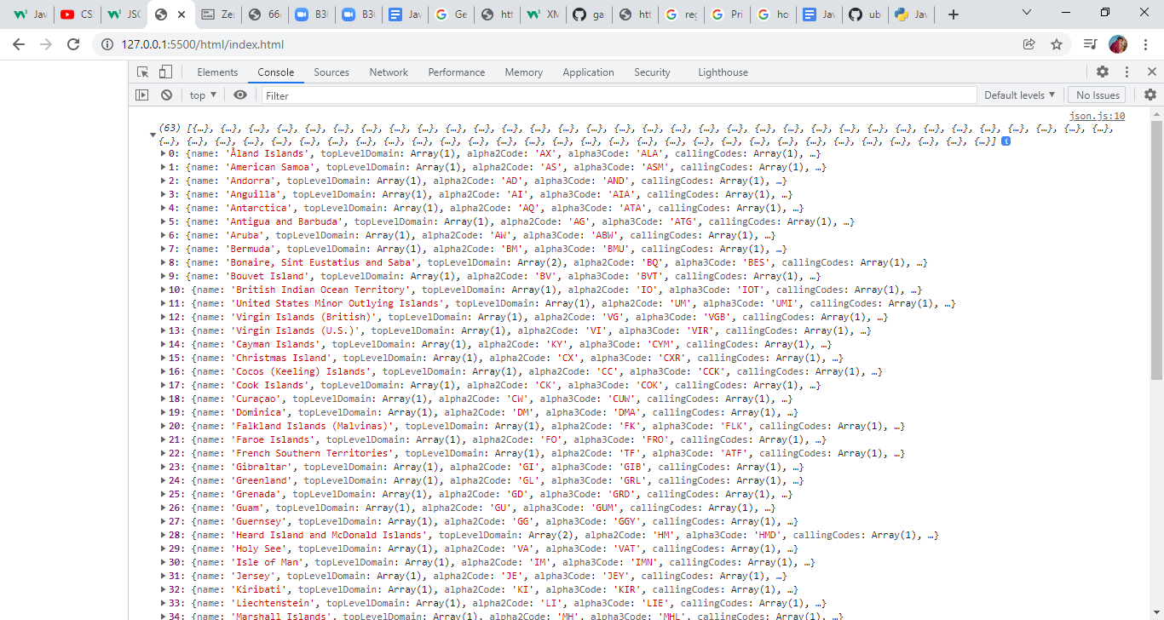

* 1. Get all the countries with a population of less than 2 lakhs using Filter function.

1. //sending request
2. var request=new XMLHttpRequest();
3. //opeing request path
4. request.open("GET", "https://raw.githubusercontent.com/rvsp/restcountries-json-data/master/res-countries.json",true)
5. request.send();
6. request.onload=function(){
7. //fethcing data in json format
8. var data=JSON.parse(this.response);
10. let populationofcountry=data.filter((pop)=>pop.population<200000);
11. console.log(populationofcountry);


15. }

Output:

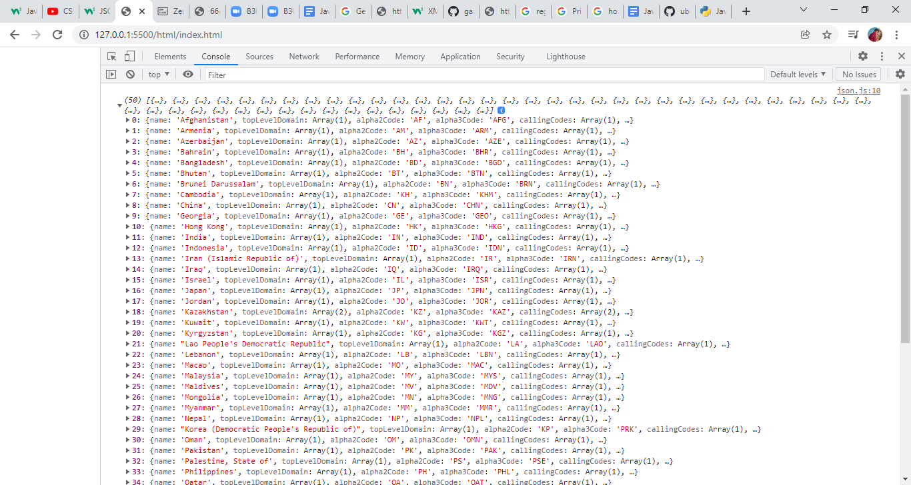

C. Print the following details name, capital, flag using forEach function.

//sending request

var request=new XMLHttpRequest();

//opeing request path

 request.open("GET", "https://raw.githubusercontent.com/rvsp/restcountries-json-data/master/res-countries.json",true)

 request.send();

 request.onload=function(){

     //fethcing data in json format

     var data=JSON.parse(this.response);

     let fun=data.forEach(function(num){

        console.log(`

        name:${num.name}

        capital:${num.capital}

        flag:${num.flag}

        `)

    });

Output:

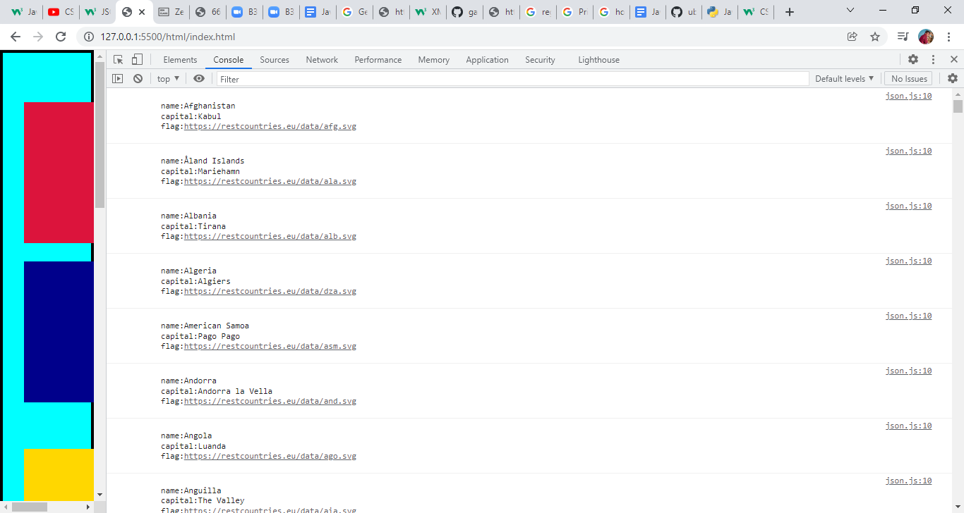

D. Print the total population of countries using reduce function.

//sending request

var request=new XMLHttpRequest();

//opeing request path

 request.open("GET", "https://raw.githubusercontent.com/rvsp/restcountries-json-data/master/res-countries.json",true)

 request.send();

 request.onload=function(){

     //fethcing data in json format

     var data=JSON.parse(this.response);

     let value2=data.reduce(function(total,data){

        return total+data.population;

    },0);

    console.log(value2)

    };

Output:

7349137231

E. Print the country which uses US Dollars as currency.

//sending request

var request=new XMLHttpRequest();

//opeing request path

 request.open("GET", "https://raw.githubusercontent.com/rvsp/restcountries-json-data/master/res-countries.json",true)

 request.send();

 request.onload=function(){

     //fethcing data in json format

     var data=JSON.parse(this.response);

     let dollar=data.filter((data)=>data. currencies[0].symbol==='$');

   console.log(dollar)

output:

